In-Person/Virtual, Teacher Led in Small Groups/One-on-One, or Self-Paced with Teacher Oversight.
ShalomLearning partnered with JLearnHub to offer a Learn to Read program and Tefillot (Prayers). Created by Rae Antonoff, all of the materials are formatted on the principles of Accessible Design. Colors, layout, fonts, and more boost decoding success for learners with a wide range of abilities. The packets can also be printed in grayscale for learners with various forms of colorblindness.
There are online, self-paced activities for students to reinforce the learning or move ahead independently.
Learn to Read includes 41 lessons in eight colorful packets available as printable PDFs and SlideDecks for screen sharing/projecting. There is a “Silly Hebrew Trick” as a mnemonic device for the sound and shape of each letter.

Tefillot (Prayers) has a balanced emphasis on meaning-making and recitation skills. In addition to reading and chanting practice, students learn the meaning and translation for each of the 17 prayers. Each lesson ends with a way for a student to creatively connect with the prayer.
Mitkadem – In Person Hebrew Curriculum
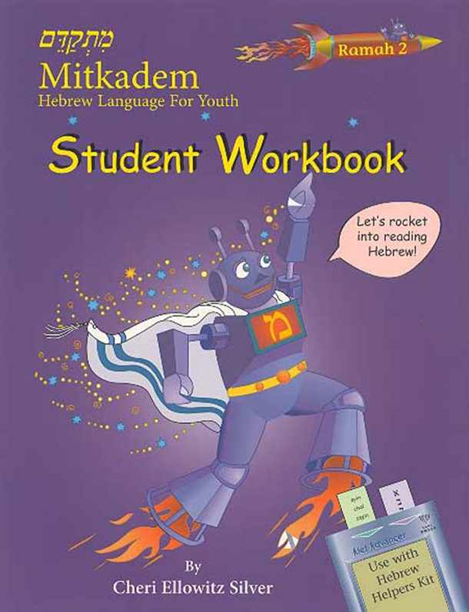Individualized, self-paced Hebrew prayer learning, for students of different learning styles and abilities.
Mitkadem is a self-paced Hebrew prayer and ritual program designed to empower every child to learn Hebrew. Created with an understanding of the realities of supplementary Jewish education (limited time, inconsistent student attendance, different levels of Hebrew knowledge, levels of motivation, and involvement with Jewish practice), Mitkadem is part of a comprehensive approach to Hebrew education.
The Mitkadem program consists of 23 levels that introduce grammar, vocabulary and reading. Students who prefer to work alone may do so, while others might be more interested in practicing reading with a partner.

